RESOLUTION NO.__________

RE: CERTIFICATE OF APPROPRIATENESS UNDER THE
PROVISIONS OF THE ACT OF THE PENNSYLVANIA
LEGISLATURE 1961, JUNE 13, P.L. 282 (53
SECTION 8004) AND BETHLEHEM ORDINANCE NO.
3952 AS AMENDED.

WHEREAS, it is proposed to construct an addition at 10 W. Fourth St.

NOW, THEREFORE, BE IT RESOLVED by the Council of the City of Bethlehem that a Certificate of Appropriateness is hereby granted for the work.

Sponsored by: (s)

(s)

ADOPTED BY COUNCIL THIS DAY OF

(s)
President of Council

ATTEST:

(s)
City Clerk

HISTORIC CONSERVATION COMMISSION

CASE # 398 – It is proposed to construct an addition at 10 W. Fourth St.
OWNER/APPLICANT: Fred Rooney / Anthony Spagnola

The Commission upon motion by Mr. Roeder and seconded by Mr. Evans adopted the proposal that City Council issue a Certificate of Appropriateness for the proposed work described herein:

- The proposal to construct an addition at 10 W. Fourth St was presented by Joe Pearl.

- The new addition to the front façade of the building will be constructed as revised in sketch A (front) and sketch B (gable ends) provided by the Historic Officer.

- The size of the addition will be adjusted to match the sketches provided and will be approximately 9’6” x 24’

- The roof will be a standing seam style roof as presented (Advantage LOK II or equivalent), and the color will be chosen at a later date.

- Half round gutters will be installed on the front of the addition.

- The fascia and gable end band will be fabricated of either break aluminum or a composite wood material such as Azek.

- A concrete or frost proof tile will be installed on the front and gable ends as per plans. The color will be chosen at the later date.

- A stucco wall finish will be used above the tile base. The stucco will match the existing in color and texture.

- The proposed work was unanimously approved as revised.

CU: cu

By: 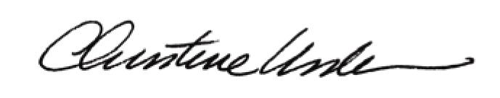

Date of Meeting: December 19, 2011 Title: Historic Officer

